Council Member Application Form
Where did you first see or hear about the ad:

The Times The Guardian Diversity Jobs ASA Website Twitter LinkedIn

Welsh publication Other, please specify:

Once form is completed please e-mail: Recruitment@ASA.Org.UK

Personal information:
Title: | Forename: |  | Surname:
Personal address:
Personal mobile: |  | Personal email:
Work address (if applicable):
Work phone: |  | Work email:

Do we need to make any special arrangements/adjustments should you be invited for interview?
Do you have a criminal record? If so, please give details (this will not necessarily bar you from appointment):
Are there any restrictions to your residence in the UK which might affect your right to take up employment in the UK? If so, please give details:
If you are successful in your application, would you require a work permit prior to taking up employment in the UK?

Educational and professional qualifications:
From – to: | Further education: | Qualifications gained:
From – to: | Secondary education: | Examinations passed:
Professional qualifications and membership of professional bodies:

Short summary of career (You may attach a CV of no more than three pages if you wish, but please do not send a covering letter):
From – to: | Name, address and nature of employment: | Position and responsibilities:

Independent (essential):
To qualify as an Independent Member, you will not have engaged in the business of marketing communications by virtue of current or previous employment by, or directorship of, or the provision of services to, an advertiser, agency or media company in marketing communications’ work. Please confirm your independence here:
Experience living/working in Wales (desirable):
If applicable, please summarise your experience living and/or working in Wales:

Additional information:
Please summarise any public or voluntary service you have undertaken (e.g. magistrate, chairman of school governors, councillor, consumer advice/advocacy or office holder in voluntary body).

Referee details:
Please name two referees, both from a professional capacity, whom we can approach now or later. Please indicate if we can take up the reference prior to an offer being made.
Yes/No

Yes/No

Personal statement:

Please outline how you meet the requirements for a Council member, which are set out in the candidate pack, and why you wish to serve (no more than 300 words, please):

Once form is completed please e-mail: Recruitment@ASA.Org.UK

Data Protection

If you apply for a role at the ASA we will collect the following information to enable us to process your application efficiently and provide you with additional information: Your name (forename, last name, other names); Your title; Your contact details (including address, town, county, post code, email address and contact telephone number); Other personal data (Including nationality, gender and date of birth); Special category data (used for monitoring purposes, including ethnic origin, religion and sexual orientation); Any additional information required to process your application, including a question on your right to work, any disability (optional), qualifications (secondary, further education or professional), career history, skills and experience for the role and where you saw the advertisement.

Where we request Special category data, you have the option in each case to select ‘other’ or ‘prefer not to say’.
If you are selected for interview then we have a legal obligation to collect and process information which proves your right to work including a work permit, copy of a passport or a copy of a visa, and will do so on the basis of this legal obligation.
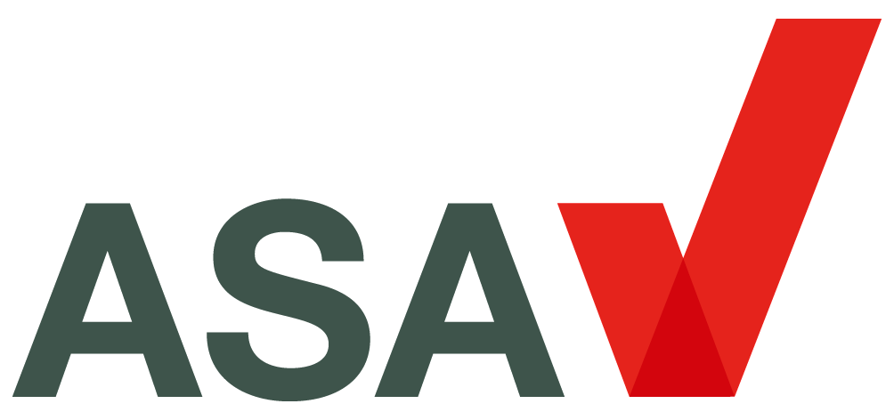

Equality, Diversity and Inclusion Monitoring Form

The Advertising Standards Authority is an equal opportunities employer and wishes to reflect the diversity of our modern society. Applications are welcomed from all sections of the community.

Date of Birth:

Gender

Female Male Prefer not to say Other* please specify:

Ethnicity
Please tick the category that you feel best describes your ethnic origin:

White Black or Black British
British Caribbean
Irish African
Other White Background* Other Black Background*

Mixed Asian or Asian British
White & Black Caribbean Indian
White & Black African Pakistani
White & Asian Bangladeshi
Other Mixed Background* Other Asian Background*

Chinese Prefer not to say and other
Chinese Prefer not to say
Other* please specify:

Sexual Orientation
Heterosexual Lesbian, Gay or Bisexual Prefer not to say Other* please specify:

Religion
No Religion Muslim
Buddhist Sikh
Christian Prefer not to say
Hindu Other, please specify:
Jewish

Disability
The Equality Act 2010 defines disability as ‘A physical or mental impairment which has a substantial and long-term effect on the person’s ability to carry out normal day-to-day activities’.

Do you consider yourself to have a disability? Yes No Prefer not to say

If yes, please specify:

Thank you for your co-operation. We treat your response as confidential and use it for monitoring purposes only. Please note that we will not identify you in any Equality, Diversity and Inclusion Reports we distribute or publish.

